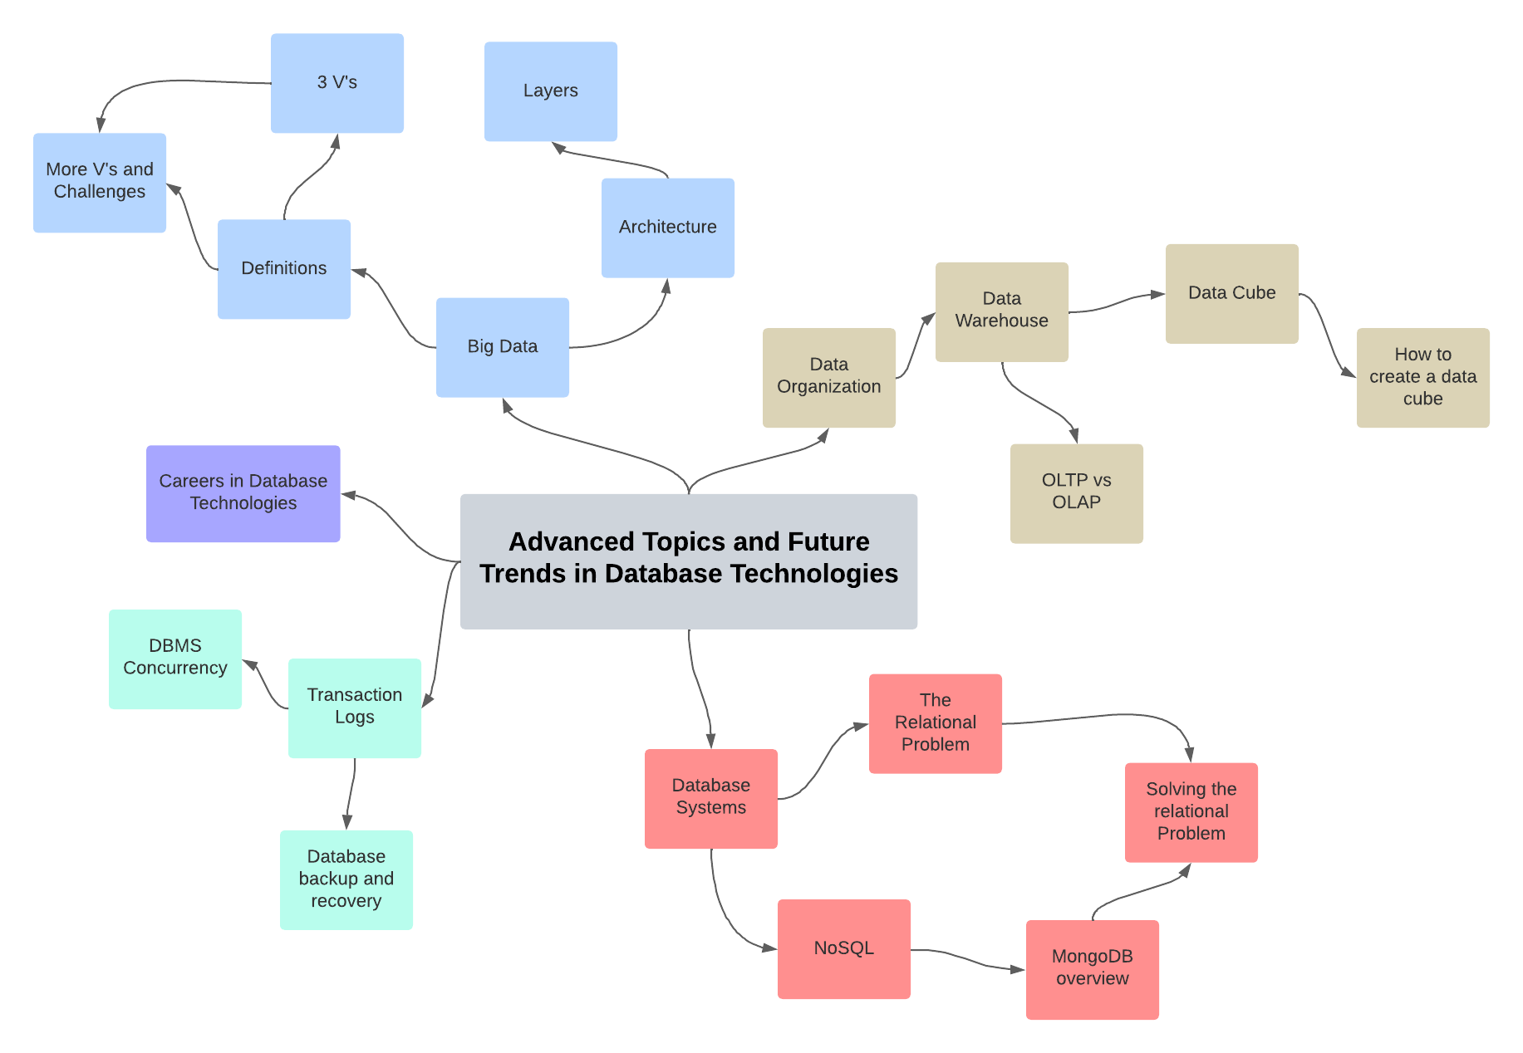

**Concept Map Explanation**

This concept map outlines advanced topics in database technologies. Central to the map is Big Data, with its foundational 3 Vs—Volume, Velocity, Variety—and additional complexities. It connects to data organization, highlighting the importance of structured storage like data warehouses. Data cubes, linked to warehouses, emphasize multidimensional data structuring for enhanced analysis.

The map contrasts OLTP (Online Transaction Processing) systems, designed for managing transactions, with OLAP (Online Analytical Processing) systems, tailored for data analysis. It acknowledges "The Relational Problem" with traditional databases, noting issues with scalability and flexibility.

NoSQL databases are presented as solutions to the relational limitations, offering horizontal scalability and varied data structure handling, with MongoDB cited as a prime example. Tied to database management are DBMS Concurrency and Transaction Logs, essential for maintaining data integrity and recovery across simultaneous operations.

Lastly, the concept map acknowledges the career opportunities in database technology and underscores the need for robust backup and recovery plans to safeguard data.

In the concept map, a Data Warehouse is placed as a critical node within the data organization category, serving as a central repository where large volumes of data from multiple sources are integrated, stored, and prepared for analysis. It is shown as the foundation for data cubes, which are specialized structures in the warehouse for organizing data in a multidimensional manner, enabling complex queries and analysis, facilitating a deeper understanding of business insights through OLAP systems.

This data warehouse node is also juxtaposed with the concept of Big Data, suggesting that it is designed to handle the immense volume, velocity, and variety that characterize Big Data challenges. It acts as a bridge between the massive, often unstructured data sets of Big Data and the structured, query-optimized environment needed for strategic business analysis.

The concept map's flow shows that knowledge of data warehousing is pivotal for understanding how businesses transform raw data into actionable insights. The placement shows a transition from the theoretical aspects of Big Data to the practical applications of that data, underscoring the data warehouse's role as an enabler of data-driven decision-making processes within organizations.